**Lab 3 IP**

**Objectives**

In this lab, we’ll investigate the IP protocol, focusing on the IP datagram. We’ll do so by analyzing a trace of IP datagrams sent and received by an execution of the traceroute program (the traceroute program itself is explored in more detail in the Lab 3 ICMP lab). We’ll investigate the various fields in the IP datagram, and study IP fragmentation in detail.

Before beginning this lab, please first review sections 1.4.3 in the textbook and section 3.4 of RFC 2151 to update yourself on the operation of the traceroute program. Please also review Section 4.3 of the textbook, and have RFC 791 on hand as well, for a discussion of the IP protocol.

**Procedures**

**1. Capturing packets from an execution of traceroute**

In order to generate a trace of IP datagrams for this lab, we’ll use the traceroute program to send datagrams of different sizes towards some destination, *X*. Recall that traceroute operates by first sending one or more datagrams with the time-to-live (TTL) field in the IP header set to 1; it then sends a series of one or more datagrams towards the same destination with a TTL value of 2; it then sends a series of datagrams towards the same destination with a TTL value of 3; and so on. Recall that a router must decrement the TTL in each received datagram by 1 (actually, RFC 791 says that the router must decrement the TTL by *at least* one). If the TTL reaches 0, the router returns an ICMP message (type 11 – TTL-exceeded) to the sending host. As a result of this behavior, a datagram with a TTL of 1 (sent by the host executing traceroute) will cause the router one hop away from the sender to send an ICMP TTL-exceeded message back to the sender; the datagram sent with a TTL of 2 will cause the router two hops away to send an ICMP message back to the sender; the datagram sent with a TTL of 3 will cause the router three hops away to send an ICMP message back to the sender; and so on. In this manner, the host executing traceroute can learn the identities of the routers between itself and destination *X* by looking at the source IP addresses in the datagrams containing the ICMP TTL-exceeded messages.

We’ll want to run traceroute and use it to send datagrams of various lengths.

* **Windows.** The tracert program (used for our ICMP Wireshark lab) provided with Windows does not allow one to change the size of the ICMP echo request (ping) message sent by the tracert program. A nicer Windows traceroute program is *pingplotter*, available both in free version and shareware versions at <http://www.pingplotter.com>. Download and install *pingplotter*, and test it out by performing a few traceroutes to your favorite sites. The size of the ICMP echo request message can be explicitly set in *pingplotter* by selecting the menu item *Edit-> Options->Default Settings->Engine* and then filling in the *Packet Size* field. The default packet size is 56 bytes. Once *pingplotter* has sent a series of packets with the increasing TTL values, it restarts the sending process again with a TTL of 1, after waiting *Trace Interval* amount of time. The value of *Trace Interval* can be explicitly set in *pingplotter*.
* **Linux/Unix/MacOS.** With the Unix/MacOS traceroute command, the size of the UDP datagram sent towards the destination can be explicitly set by indicating the number of bytes in the datagram; this value is entered in the traceroute command line immediately after the name or address of the destination. For example, to send traceroute datagrams of 2000 bytes towards gaia.cs.umass.edu, the command would be:

%traceroute gaia.cs.umass.edu 2000

Do the following:

* Start up Wireshark and begin packet capture *(Capture->Start)* and then press *OK* on the Wireshark Packet Capture Options screen (we’ll not need to select any options here).
* If you are using a Windows platform, start up *pingplotter* and enter the name of a target destination in the “Address to Trace Window.” Select the menu item *Edit-> Options->Default Settings* -> Engine and enter a value of 56 in the *Packet Size* field and then press OK. Then press the Trace button. You should see a *pingplotter* window that looks something like this:

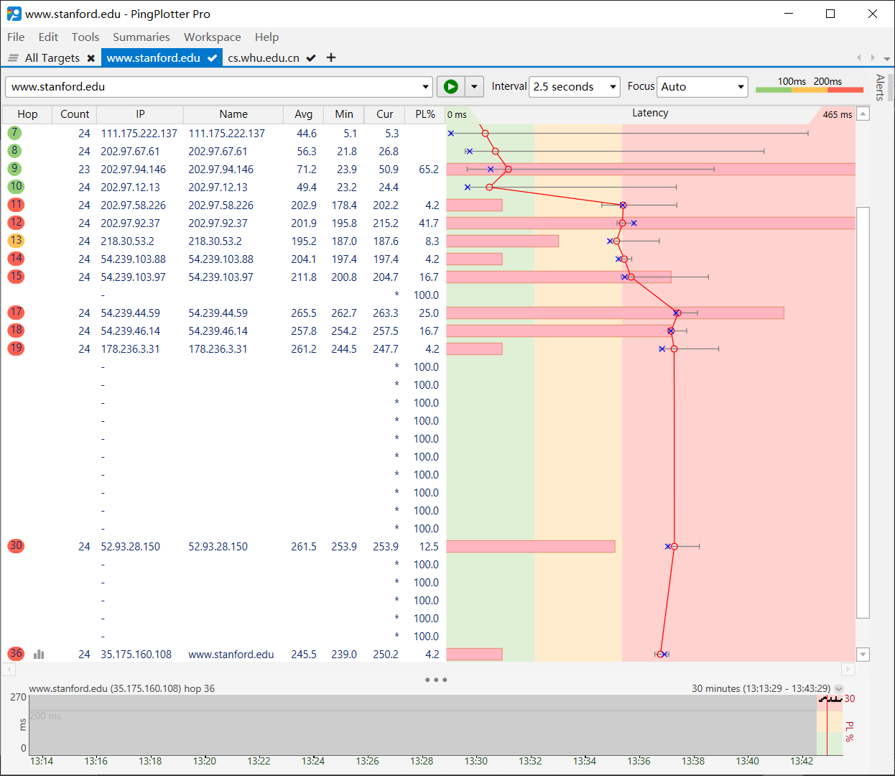

Next, send a set of datagrams with a longer length, by selecting *Edit-> Options->Default Settings -> Engine* and enter a value of 2000 in the *Packet Size* field and then press OK. Then press the Resume button.

Finally, send a set of datagrams with a longer length, by selecting *Edit-> Options->Default Settings -> Engine* and enter a value of 3500 in the *Packet Size* field and then press OK. Then press the Resume button.

Stop Wireshark tracing.

**2. A look at the captured trace**

In your trace, you should be able to see the series of ICMP Echo Request (in the case of Windows machine) or the UDP segment (in the case of Unix) sent by your computer and the ICMP TTL-exceeded messages returned to your computer by the intermediate routers. In the questions below, we’ll assume you are using a Windows machine; the corresponding questions for the case of a Unix machine should be clear. Whenever possible, when answering a question below you should hand in a printout of the packet(s) within the trace that you used to answer the question asked. When you hand in your lab report, annotate the output so that it’s clear where in the output you’re getting the information for your answer.To print a packet, use *File->Print to pdf file*, choose *Selected packet only*, choose *Packet summary line,* and select the minimum amount of packet detail that you need to answer the question.

1. Select the first ICMP Echo Request message (No. 110 in the example data) sent by your computer, and expand the Internet Protocol part of the packet in the packet details window.

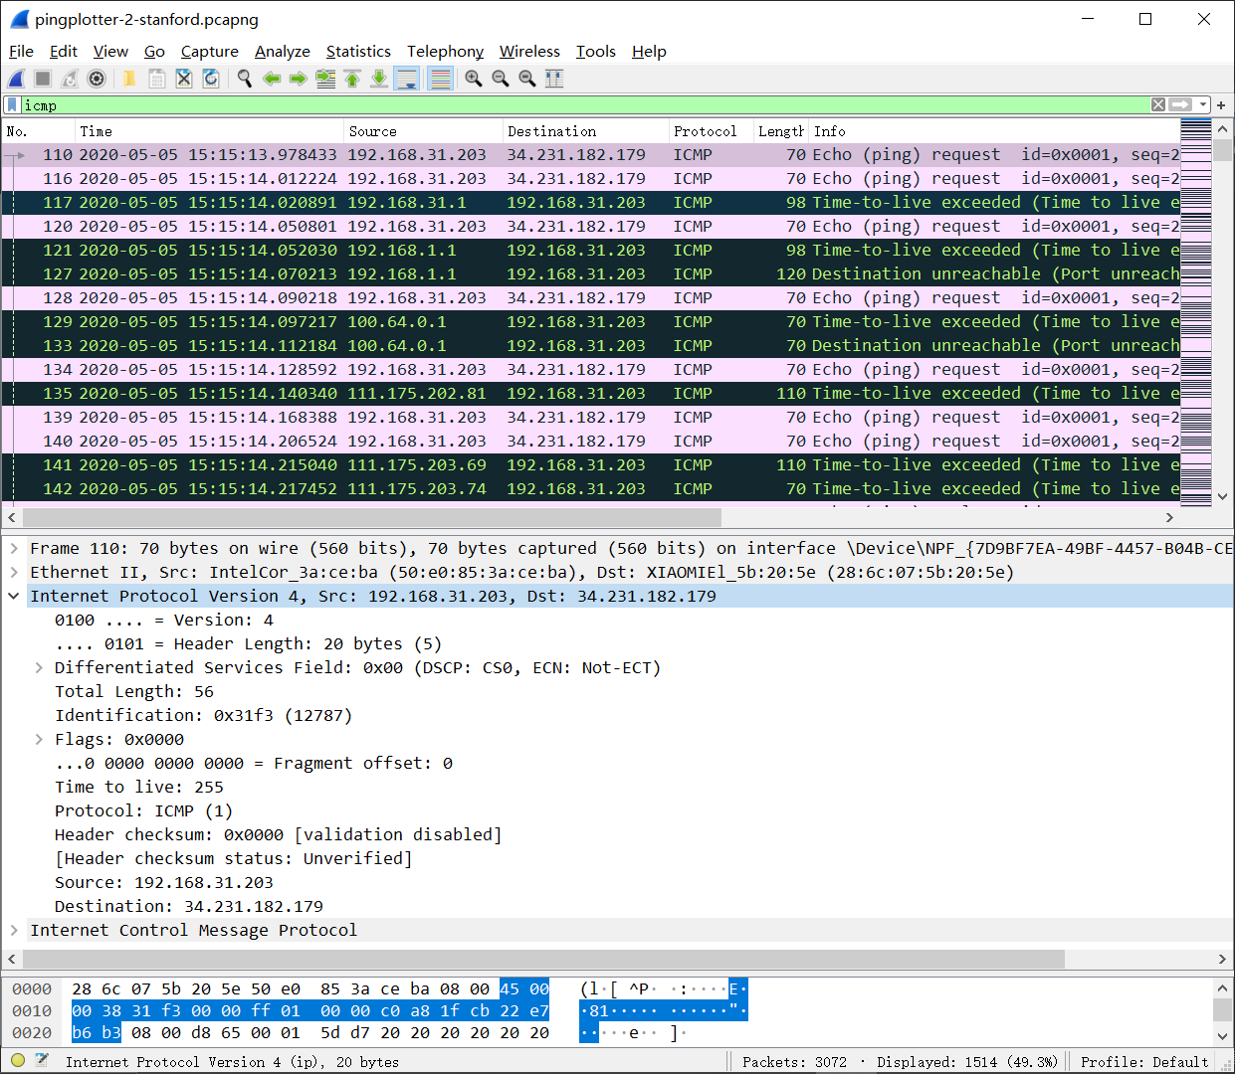

My screenshot:

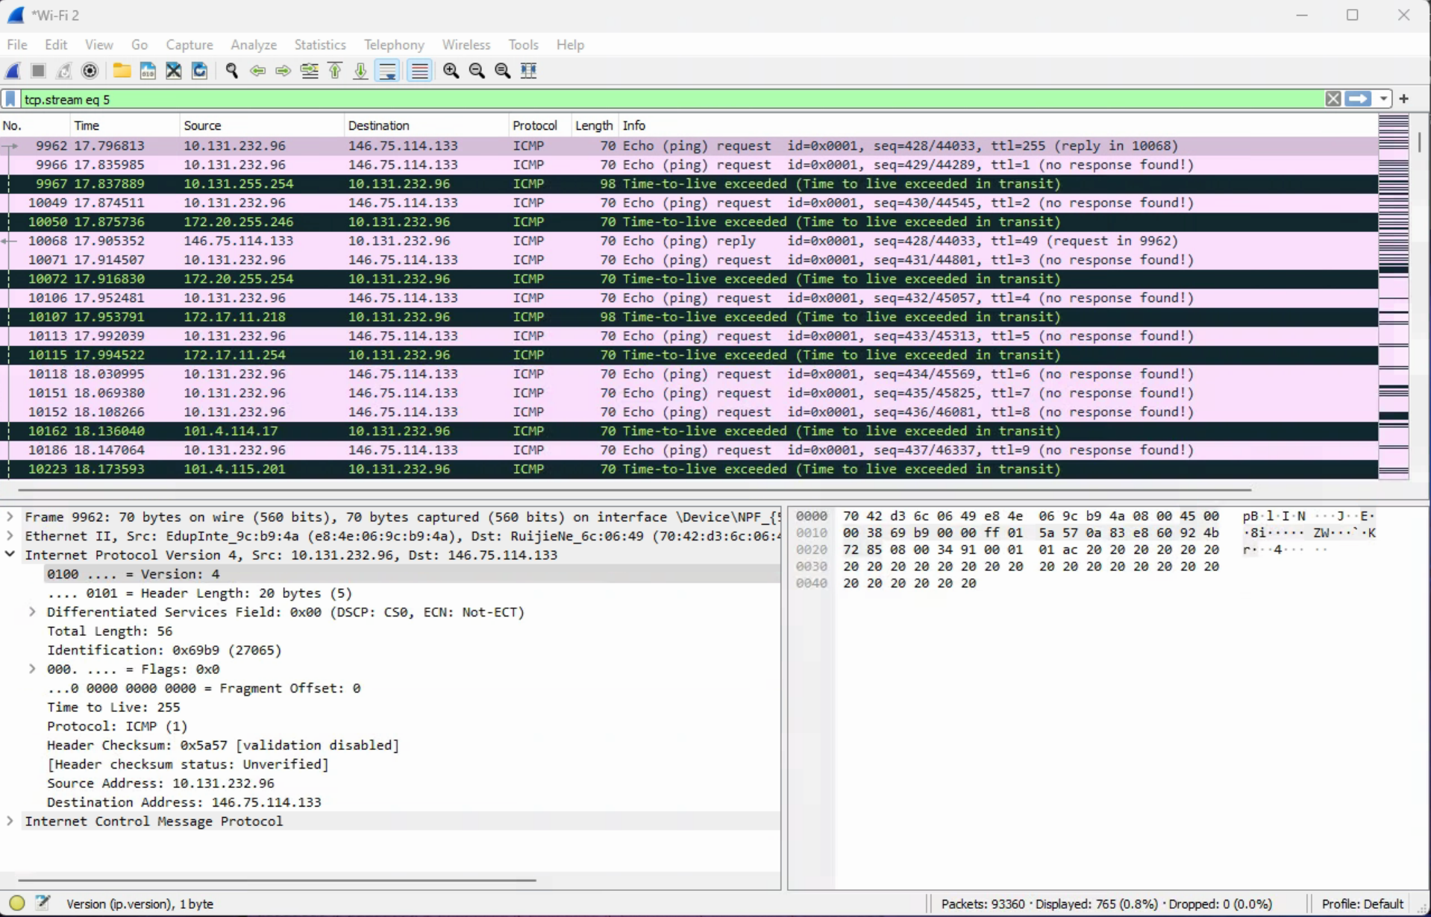

What is the IP address of your computer? **The IP Address of my computer is: 10.131.232.96**

1. Within the IP packet header, what is the value in the upper layer protocol field?

**Within the header, the value of the upper layer protocol field is ICMPP(1).**

1. How many bytes are in the IP header? How many bytes are in the payload *of the IP datagram*? Explain how you determined the number of payload bytes.

**There 20 bytes in the IP header and 56 total length. To determine the number of payload bytes: 56-20 = 36 bytes. This gives 36 bytes in the payload of the IP datagram.**

1. Has this IP datagram been fragmented? Explain how you determined whether or not the datagram has been fragmented.

**No, the data is not fragmented because the more fragments bit = 0 (not set).**

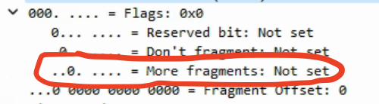

Next, sort the traced packets according to IP source address by clicking on the *Source* column header; a small downward pointing arrow should appear next to the word *Source*. If the arrow points up, click on the *Source* column header again. Select the first ICMP Echo Request message sent by your computer, and expand the Internet Protocol portion in the “details of selected packet header” window. In the “listing of captured packets” window, you should see all of the subsequent ICMP messages (perhaps with additional interspersed packets sent by other protocols running on your computer) below this first ICMP. Use the down arrow to move through the ICMP messages sent by your computer.

1. Which fields in the IP datagram *always* change from one datagram to the next within this series of ICMP messages sent by your computer?

**The identification, Time to Live (TTL), and Header checksum always changes.**

1. Which fields stay constant? Which of the fields *must* stay constant? Which fields must change? Why?

**The fields that stay constant in IP datagrams are:**

**- The version (IPv4 for all the packets)**

**- Header length (since these are all ICMP packets)**

**- Source IP (since we are sending from the same source)**

**- Destination IP (since we are sending to the same destination)**

**- Differentiated services (since all the packets are ICMP, they all use the same Type of Service class)**

**-Upper layer protocol (since they are all ICMP packets)**

**The fields that MUST stay constant in the IP datagrams are:**

**-The Version (IPv4)**

**-The Header length (since these are all ICMPP packets)**

**- source IP (since we are sending from the same source)**

**- destination IP (since we are sending to the same destination)**

**- Differentiated services (since all packets are ICMP, they all use the same Type of Service class)**

**- Upper layer protocol (since they are all ICMP packets)**

**The fields that MUST change in the IP datagrams are:**

**- Identification (because all the IP packets must have different ids)**

**- Time to Live (because traceroute each subsequent packet)**

**- The Header checksum (because since the header changes, so should the checksum)**

1. Describe the pattern you see in the values in the Identification field of the IP datagram

**The pattern is that the IP header identification fields increment with each ICMP Echo (ping) request.**

Next (with the packets still sorted by source address) find the series of ICMP TTL-exceeded replies sent to your computer by the nearest (first hop) router.

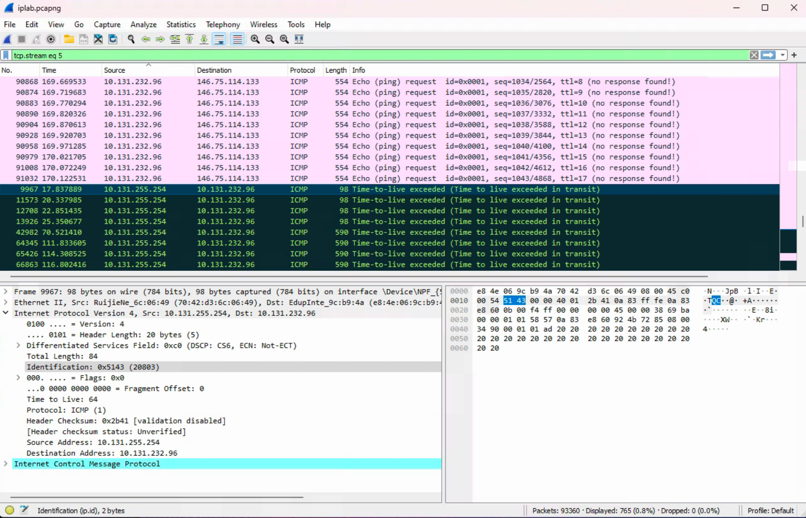

1. What is the value in the Identification field and the TTL field?

**Identification: 20803**

**Time to live: 64**

1. Do these values remain unchanged for all of the ICMP TTL-exceeded replies sent to your computer by the nearest (first hop) router? Why?

**The identification field changes for all ICMP TTL-exceeded replies sent to my computer because the identification field is a unique value. When two or more IP datagrams have the same identification value, this means that these IP datagrams are fragments of a single large IP datagram.**

**As for the TTL field, it remains unchanged because the TTL for the first hop router is always the same.**

Fragmentation

Sort the packet listing according to time again by clicking on the *Time* column.

1. Find the first ICMP Echo Request message that was sent by your computer after you changed the *Packet Size* in *pingplotter* to be 2000(No. 1027, 1026 in the example data). Has that message been fragmented across more than one IP datagram? If your computer has an Ethernet interface, a packet size of 2000 *should* cause fragmentation.[1]

**Yes, the packet has been fragmented across more than one IP datagram.**

1. Print out the first fragment of the fragmented IP datagram. What information in the IP header indicates that the datagram been fragmented? What information in the IP header indicates whether this is the first fragment versus a latter fragment? How long is this IP datagram?

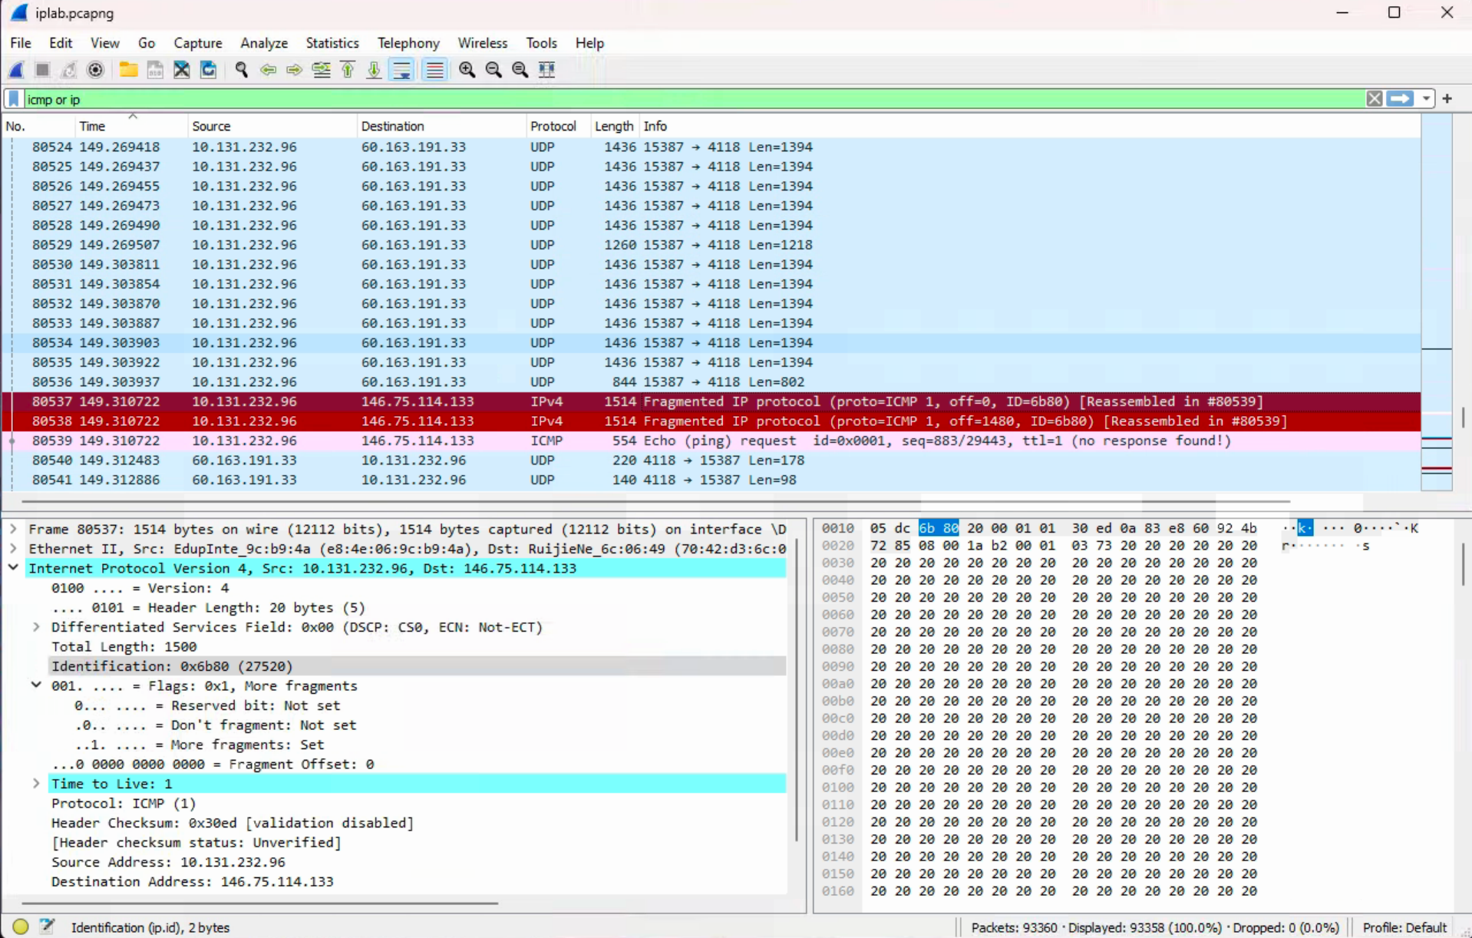

**First Fragment**

**The flag bits for more fragments is set, indicating that the datagram has been fragmented. Since the fragment offset is 0, we know that this is the first fragment. This first datagram has a total length of 1500, including the header (20 bytes).**

1. Print out the second fragment of the fragmented IP datagram. What information in the IP header indicates that this is not the first datagram fragment? Are the more fragments? How can you tell?

**I can tell that this isn’t the first datagram fragment because the fragment offset is 1480. Yes, there are more fragments because the more fragments flag is Set.**

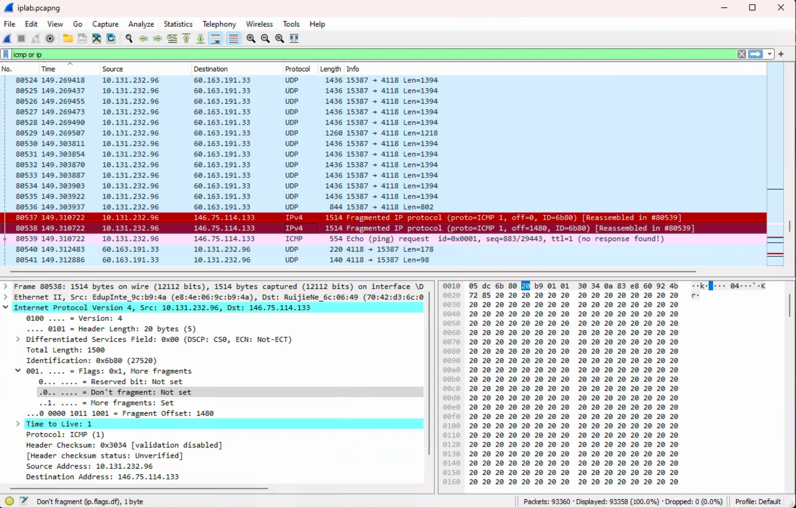

**Second Fragment**

1. What fields change in the IP header between the first and second fragment?

**The fields that changed in the IP header between the first and second fragments are: total length, fragment offset, and checksum.**

Now find the first ICMP Echo Request message that was sent by your computer after you changed the *Packet Size* in *pingplotter* to be 3500(No. 2108,2107, 2106 in the example data).

1. How many fragments were created from the original datagram?

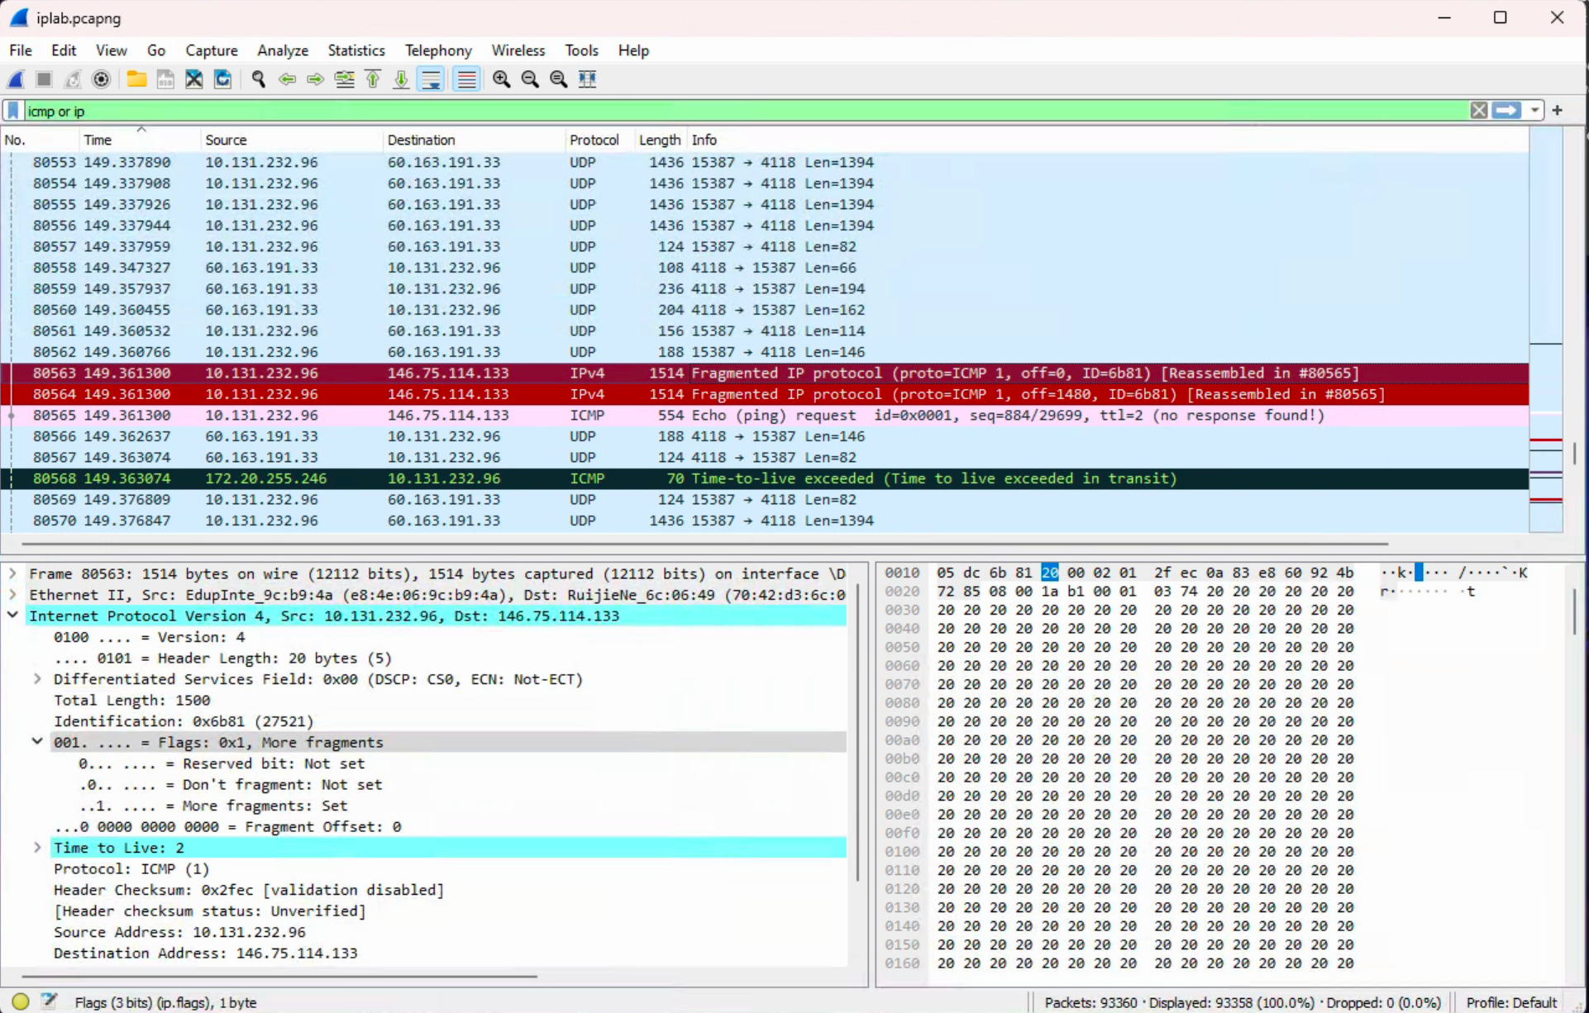

**After switching to 3500, there are 3 packets (fragments) created from the original datagram.**

1. What fields change in the IP header among the fragments?

**The IP header fields that changed among the fragments are: fragment offset and checksum. Between the first two packets and the last packet, I can see a change in total length (1500-> 540) and flags (0x1 -> 0x0). Also, between the first two packets and the last packet, the more fragments bit is to set to 1 then 0 for the last packet.**

1. This is because the computer on which the trace was gathered has an Ethernet card that limits the length of the maximum IP packet to 1500 bytes (40 bytes of TCP/IP header data and 1460 bytes of upper-layer protocol payload). This 1500 byte value is the standard maximum length allowed by Ethernet.